# Лаб.3 - Hacking at RobberCity

**Єлін Євген РІ-41мн**

<https://github.com/YelinYevgen/lab-3.git>

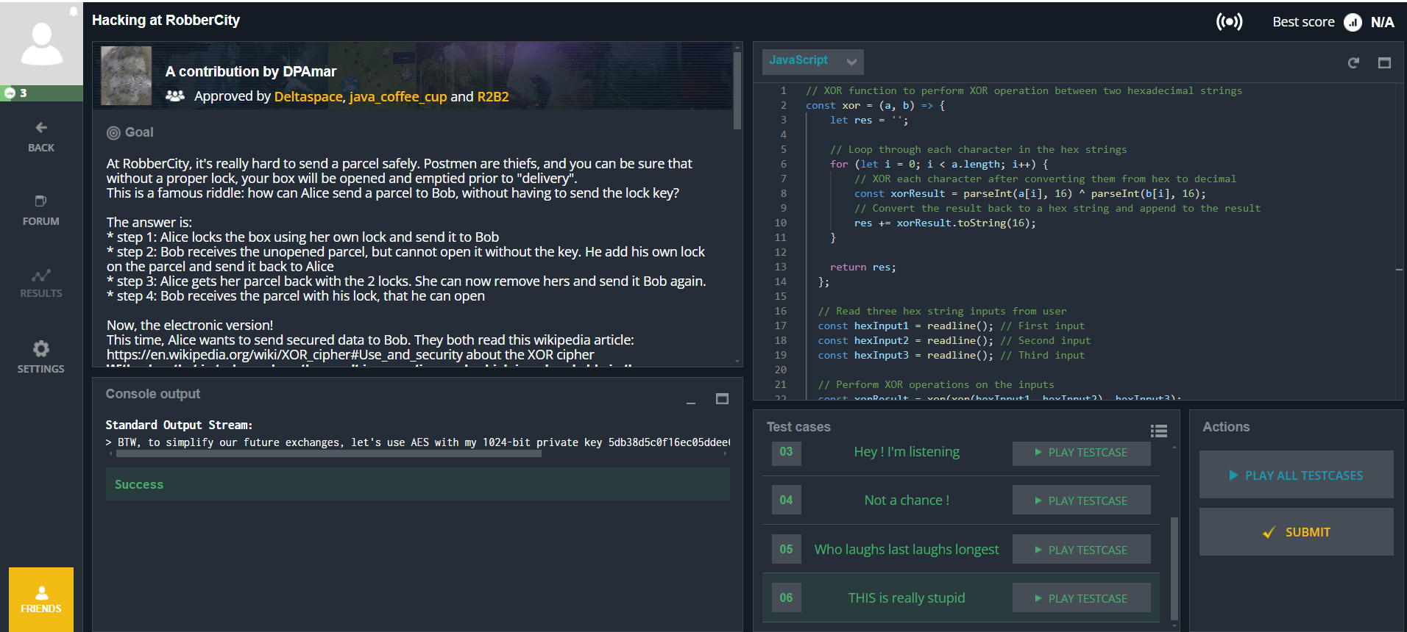

**Код на JavaScript:**

// XOR function to perform XOR operation between two hexadecimal strings

const xor = (a, b) => {

let res = '';

// Loop through each character in the hex strings

for (let i = 0; i < a.length; i++) {

// XOR each character after converting them from hex to decimal

const xorResult = parseInt(a[i], 16) ^ parseInt(b[i], 16);

// Convert the result back to a hex string and append to the result

res += xorResult.toString(16);

}

return res;

};

// Read three hex string inputs from user

const hexInput1 = readline(); // First input

const hexInput2 = readline(); // Second input

const hexInput3 = readline(); // Third input

// Perform XOR operations on the inputs

const xorResult = xor(xor(hexInput1, hexInput2), hexInput3);

// Convert the hex result into ASCII characters

// Each two hex digits represent one ASCII character

const asciiResult = xorResult.replace(/../g, hexPair =>

String.fromCharCode(parseInt(hexPair, 16))

);

// Output the final readable ASCII result

console.log(asciiResult);